1. Review from p.31 to p.40 in the text book.

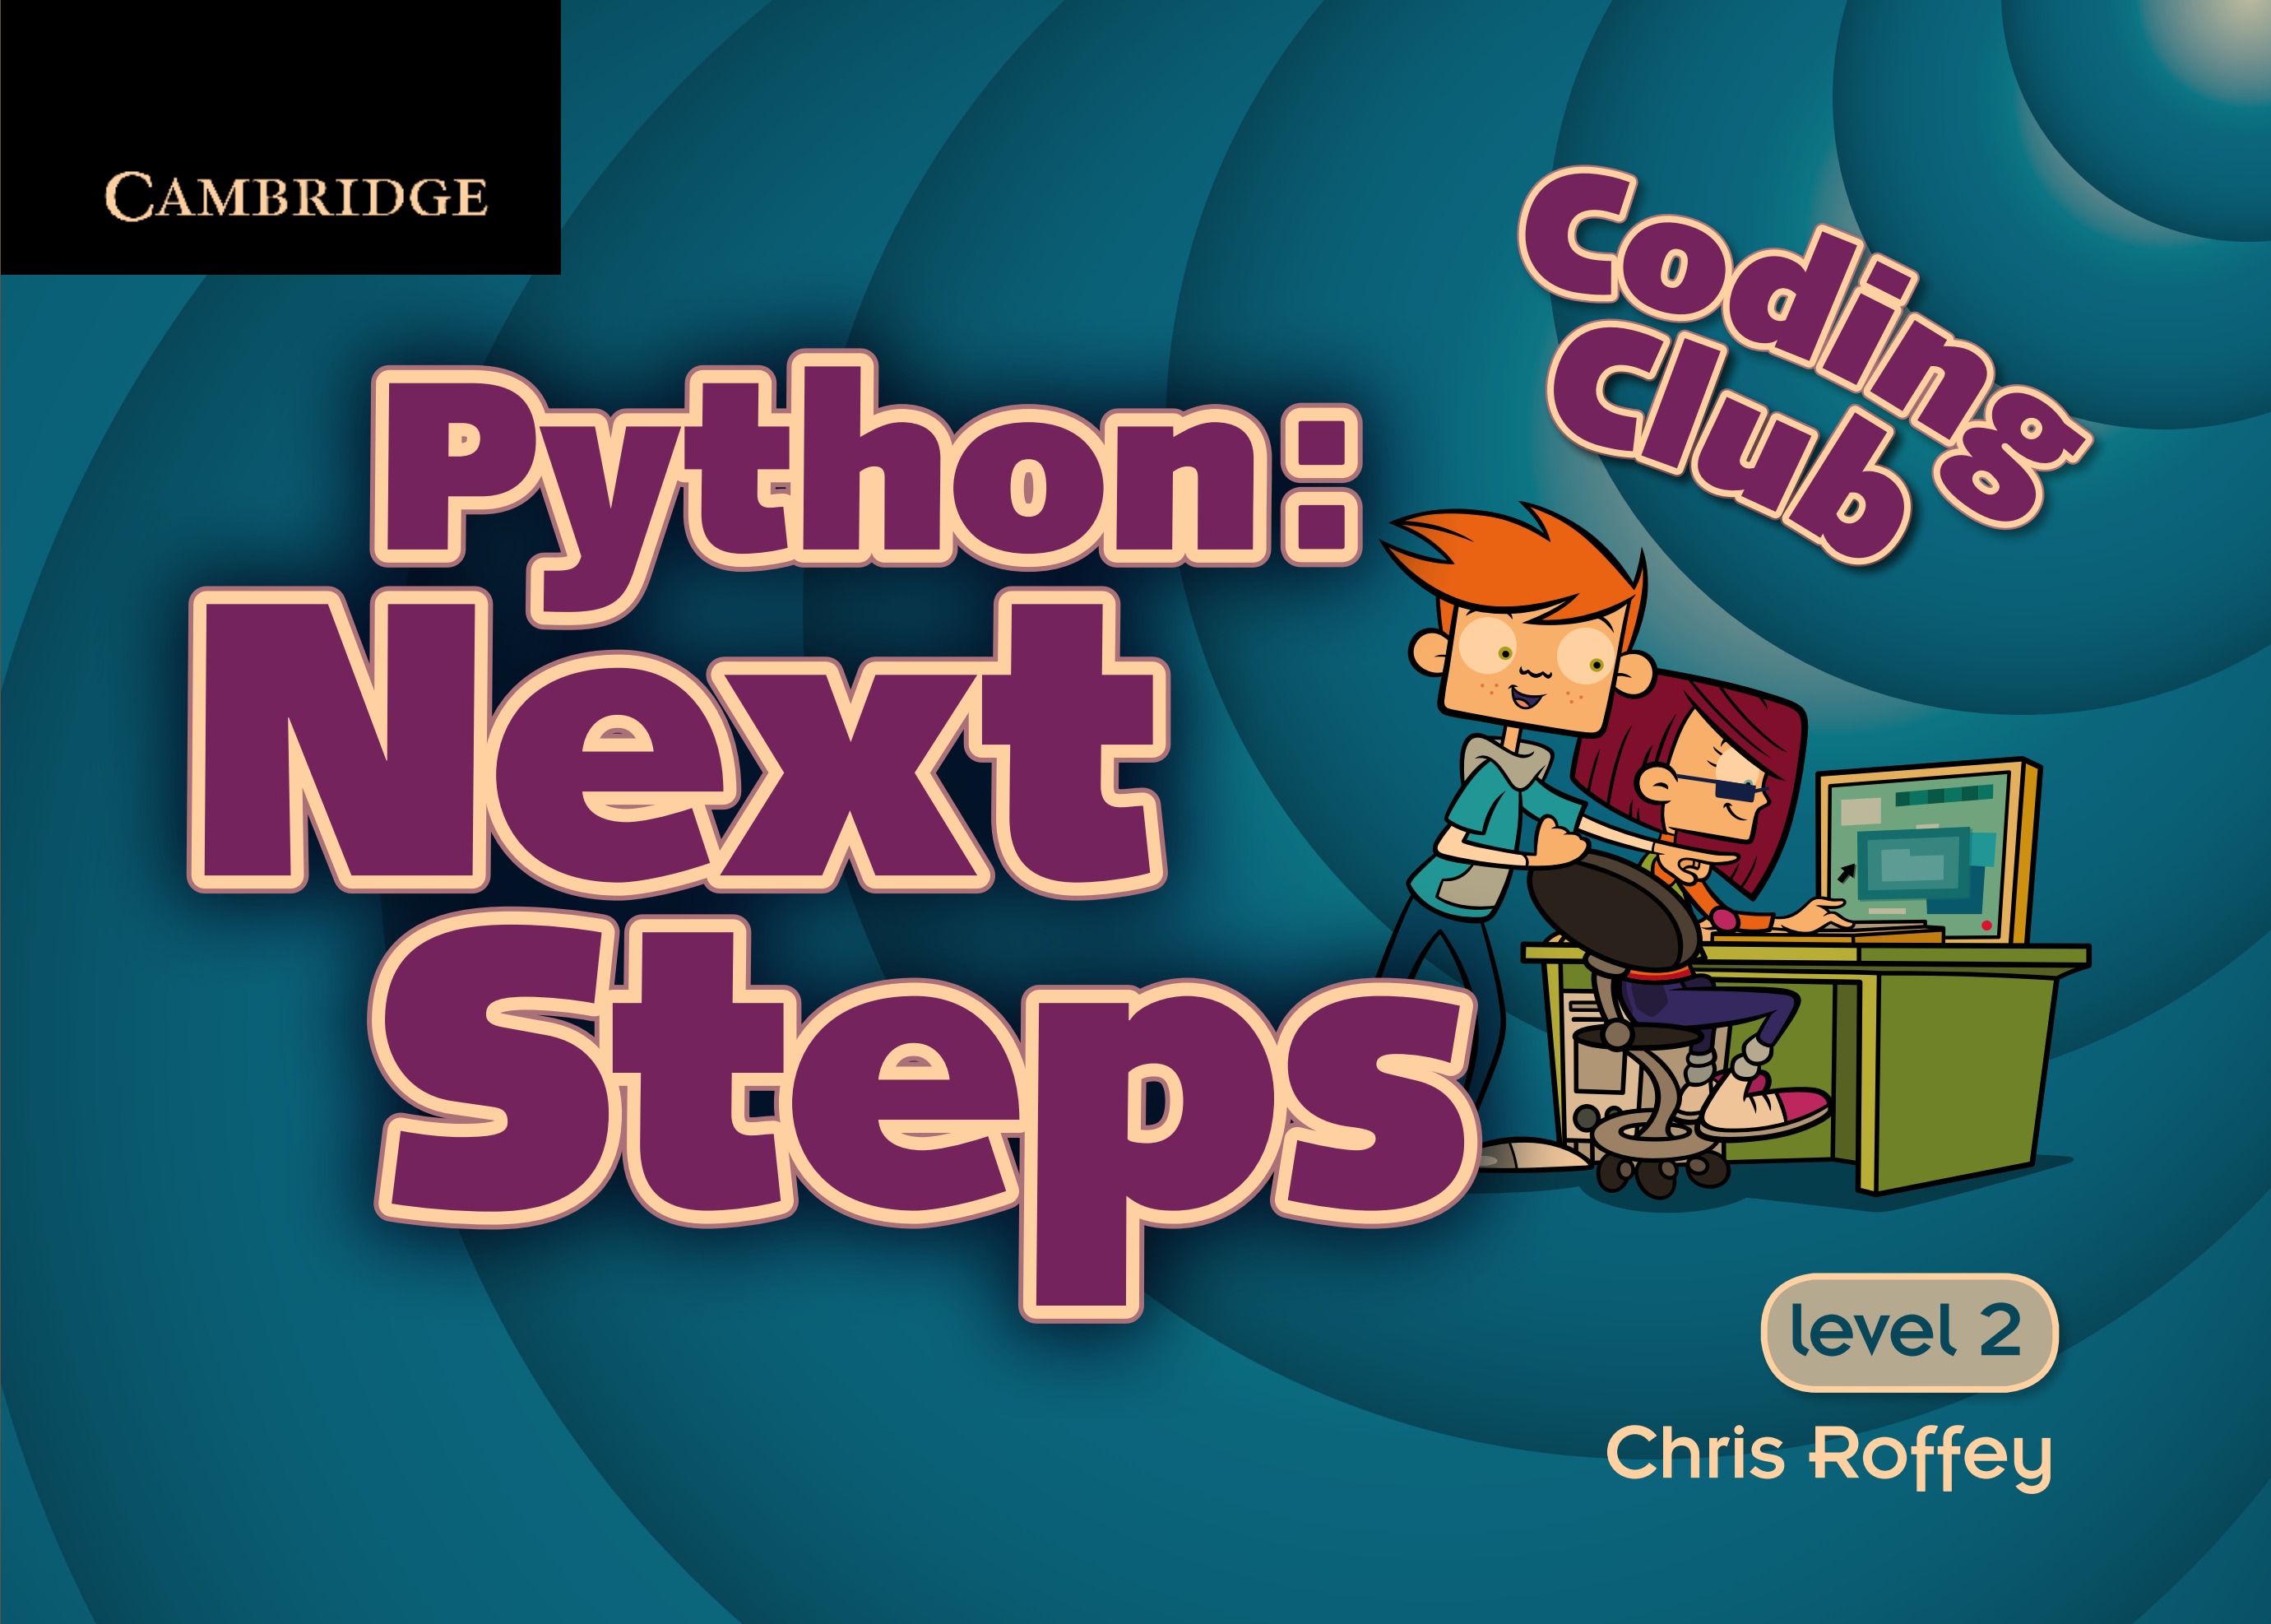

1. Summarize the concepts you think are important among those contents.